St Mary's Graveyard Project
Cowtown, Higher Brixham

Why needed ?
During the Second World War, St Mary's Graveyard records were destroyed in the ‘Exeter Blitz’. The Churchwardens are frequently asked the whereabouts of family plots recorded in the Church burial records, but the actual locations were unknown.



Who will it help ?
Anyone wanting to pay respects at their family's grave will now be able to find them.
Family Historians can find their ancestors.
Where it is recorded, researchers should be able to search for those lost at sea, killed in action, died of Cholera etc.
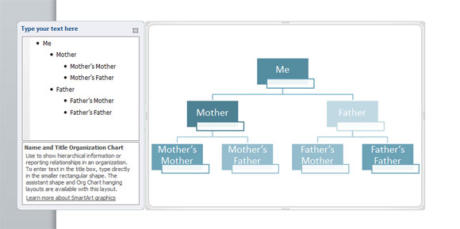
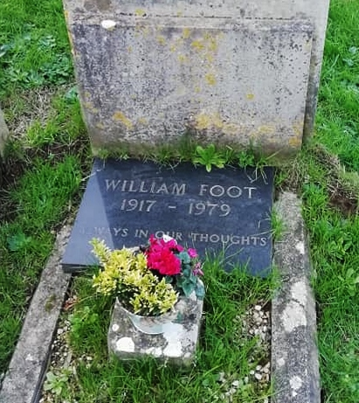
What has been recorded ?
All relevant information from the memorial inscriptions has been recorded where they exist.
Surname, first name, middle name, date of death, age, relationship to others on the stone along with any other details about their life or death.
