St Mary's Graveyard Project
Cowtown, Higher Brixham

The plan of action
The Graveyard covers nearly three acres, over various plots, and contains memorial stones from the early 1700’s. It quickly became obvious each plot contained consecutive stones with dates ranging over 300 years and rarely in neat rows.

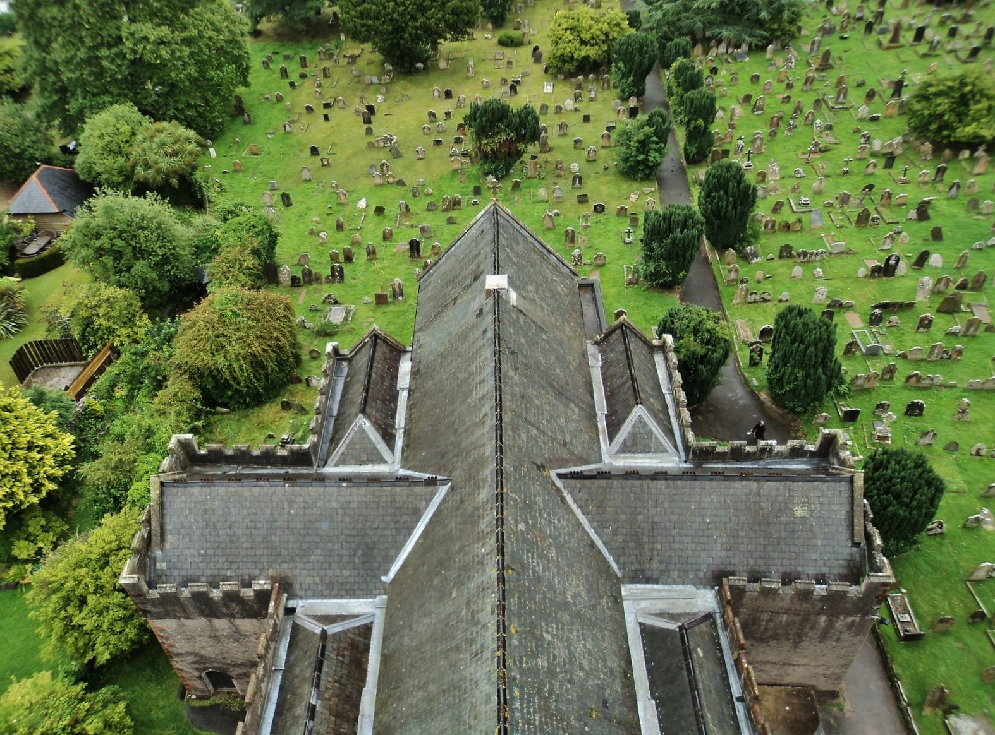

Volunteers decided it would be necessary to record all memorial inscription details found in the Graveyard. Pinpointing just the Victorians would be impossible.

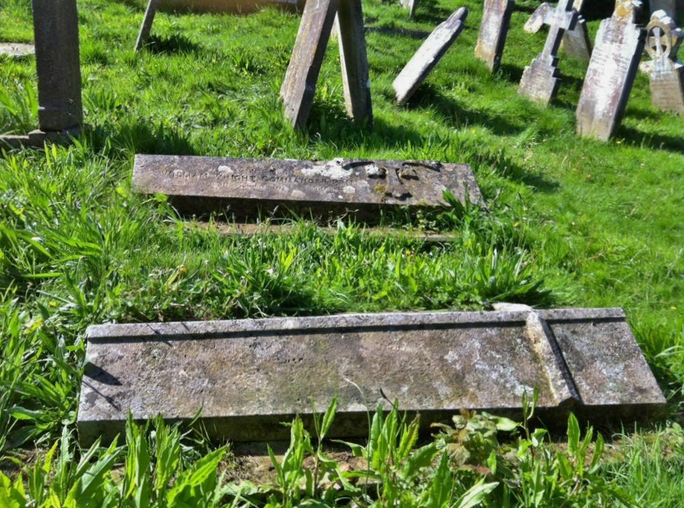
The Church and Graveyard was divided into 12 different plots, each given a number.
Each row of gravestones was given an alphabetical reference but as few rows are straight some estimation was required.
Each burial plot, traditionally 2 ½ feet wide, was then given a number whether there was a memorial stone there or not.
This will leave each burial plot with a unique reference.
Recorded on a database, every name will be searchable giving the unique plot reference.

