St Mary's Graveyard Project
Cowtown, Higher Brixham

Sucesses
Once all had been read, recorded, checked, returned to and checked again, the information was added to a speadsheet to create a full database of all the memorial inscriptions in St Mary's Graveyard.
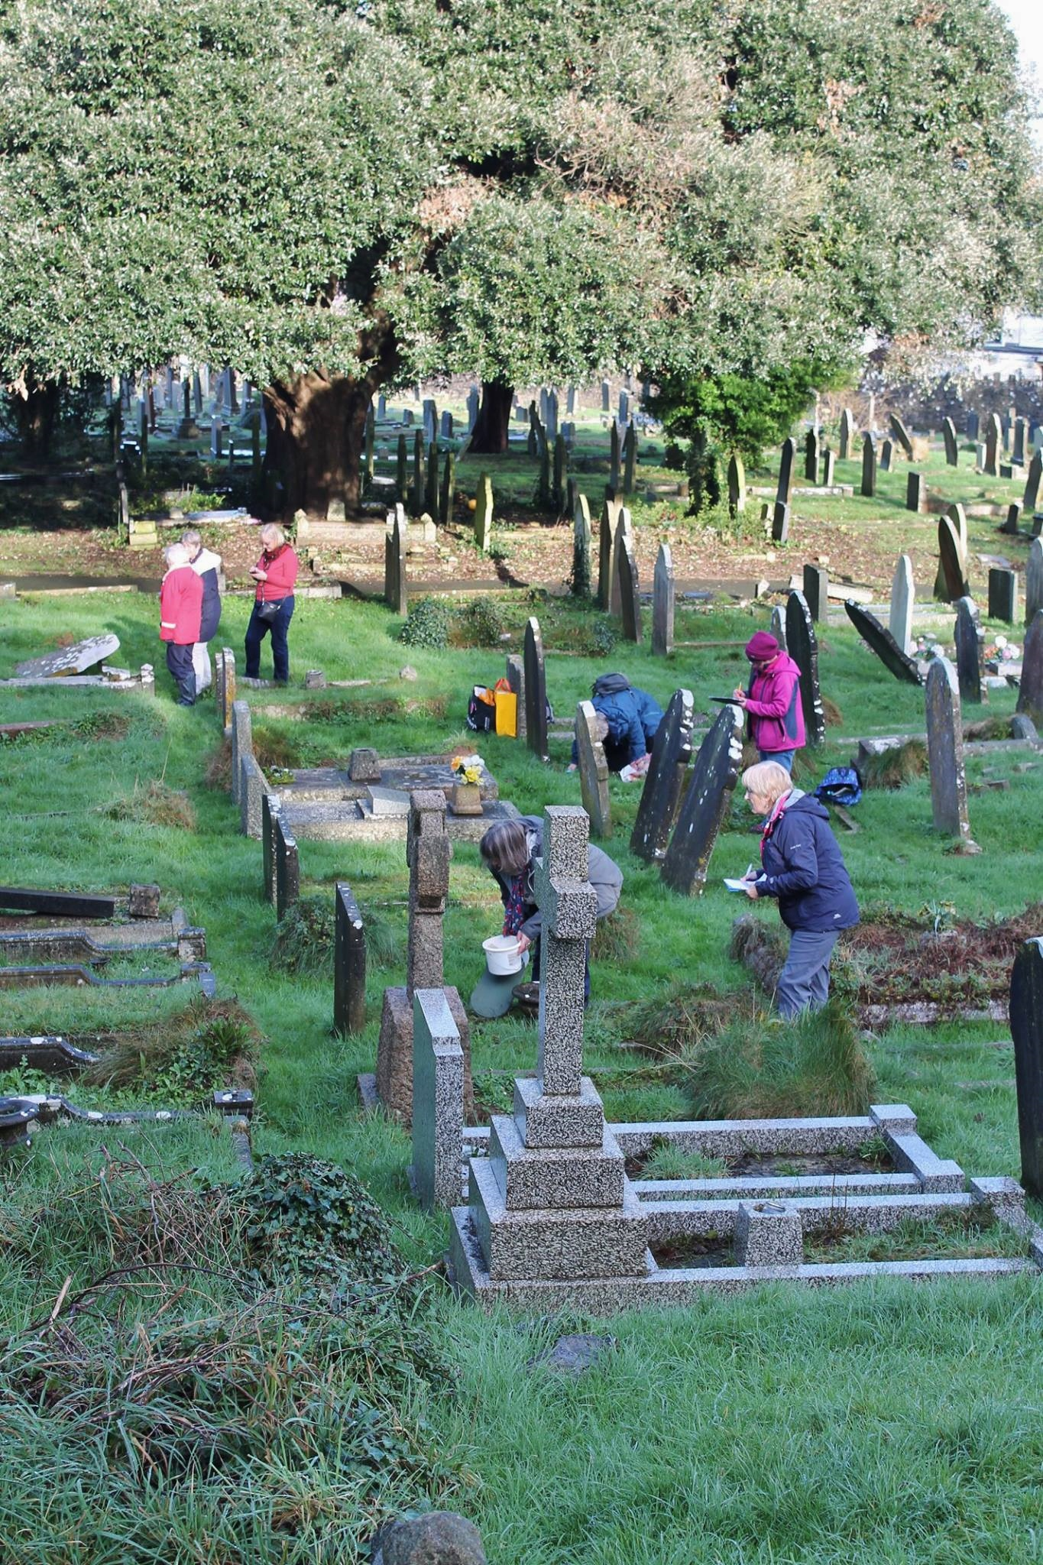
Ever changing, we can only say the database is accurate to 2018.

Every effort has been made to make sure the details are as accurate as possible but any errors may be ours or due to the original stone mason !

